**Summary —** **Chapter 2: Introduction to proof**

**Number systems and writing propositions**

* The set of real numbers, , can be represented on the number line and the set includes all rational and irrational numbers.
* The set of integers, , are all the positive and negative whole numbers, it can be divided into the subsets of positive integers (or natural numbers), represented by  (or ), and negative integers, represented by . In set notation:  
    
      
  
* .
* The set of rational number, , includes all the numbers that can be expressed as the quotient of two integers,  and , where  and  and have no common factors (except 1). In set notation: .
* Some rational numbers can be expressed as terminating decimals, e.g. .
* Some rational numbers can be expressed as recurring decimals (non-terminating or periodic decimals), e.g.  or .
* Any real number that is not a rational number is an irrational number. Surds  and decimals that neither terminate nor recur, such as  and , are included in the set of irrational numbers, which can be denoted as  or .

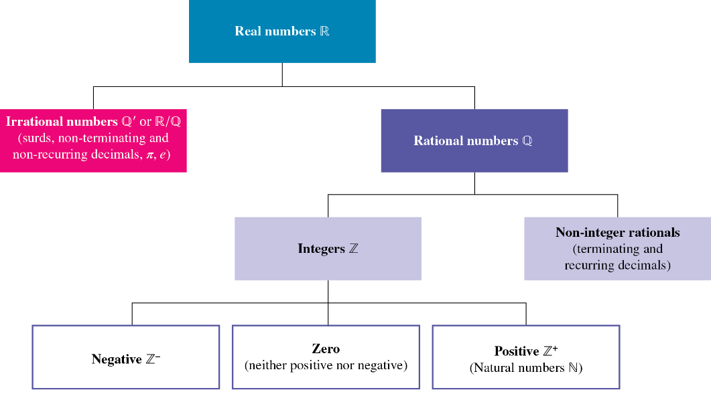

* A proposition or mathematical statement is a sentence that is either true or false. It may contain words and symbols. ‘5 is a prime number’ is a true statement while ‘17 is a multiple of 3’ is a false statement.
*  or  is true means that at least one of them is true (they both might be true). This is represented in a Venn diagram as ‘ or ’=.

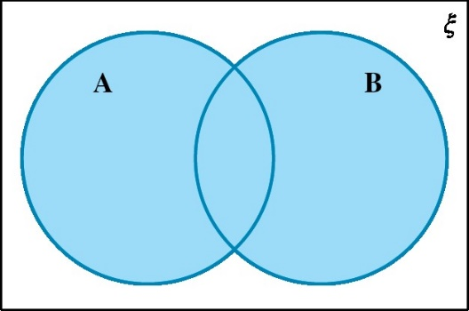

And a truth table displaying all the true/false combinations for  or  is as follows.

|  |  |  |
| --- | --- | --- |
| **A** | **B** | **A or B** |
| T | T | T |
| T | F | T |
| F | T | T |
| F | F | F |

*  and  is true means that both of them are true. This is represented in a Venn diagram as ‘ and ’=.

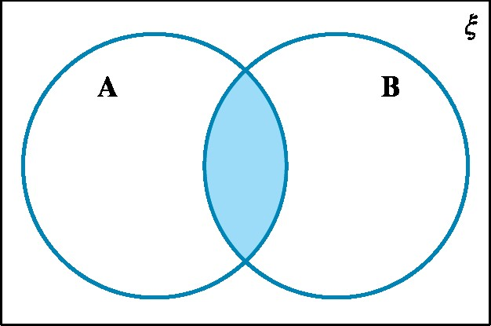

And a truth table displaying all the true/false combinations for  and  is as follows.

|  |  |  |
| --- | --- | --- |
| **A** | **B** | **A and B** |
| T | T | T |
| T | F | F |
| F | T | F |
| F | F | F |

* The negationof a true statement is false, and the negation of a false statement is true. The negation of statement  is written as .

|  |  |
| --- | --- |
| **A** | **¬A** |
| T | F |
| F | T |

can be represented in a Venn diagram as .

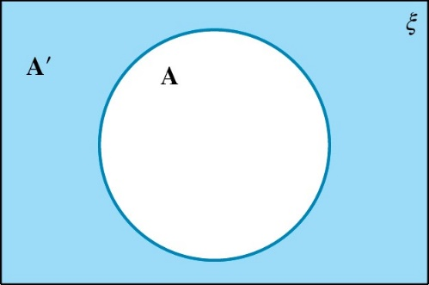

* The negation of the statement ‘ or ’ becomes ‘not  and not ’. ( or ) is the same as  and . It can be represented on a Venn diagram as .

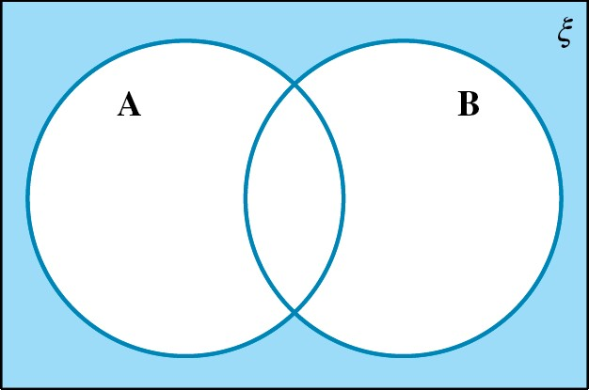

* The negation of the statement ‘ and ’ becomes ‘not  or not ’. ( and ), is the same as  or . It can be represented on a Venn diagram as .

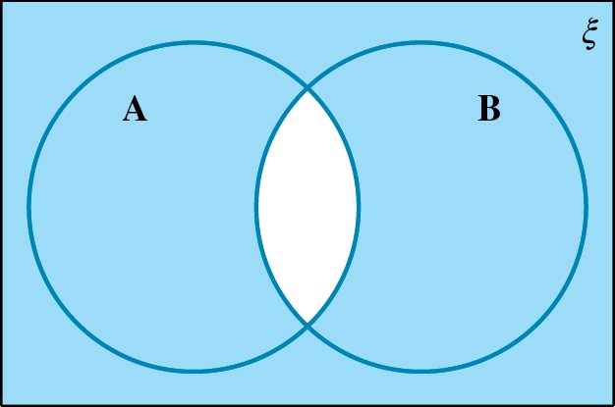

* Statements using implication(also called implicative statements) are normally written in the form ‘if P, then Q’ (P ⇒ Q), where P is generally referred to as the hypothesis, and Q as the conclusion.
* The converse of the statement ‘if P, then Q’ is ‘if Q, then P’ or Q ⇒ P. The converse of a statement may or may not be true.
* If P ⇒ Q and Q ⇒ P, then P and Q are said to be equivalent statements.
* The universal quantifier, *for all*, is written with the symbol ∀. This means that all possible values for the variable are considered.
* The existential quantifier, *there exists*, is written with the symbol ∃. This means that there is a value for the variable that would make the propositional function true.
* The existential quantifier can also be negated using the symbol ∄. This means that ‘there does not exist’.
* If combining quantifiers of the same type, the order can be changed.
* If combining different quantifiers, the order cannot be changed.

**Direct proofs using Euclidean geometry**

* The direct proof method is:   
  1. Identify the statements P and Q and assume that P is true.

2. Use the fact that P is true to directly show that Q is true.

3. Therefore P ⇒ Q is true. This completes the proof.

* An even number is an integer such that , where is an integer.
* An odd number is an integer such that , where is an integer.
* Axioms and postulates are basic statements that are accepted as true without proving them.

|  |  |  |
| --- | --- | --- |
| 1 | Angles on a straight line are supplementary. | C:\Users\nr.vignesh\AppData\Local\Packages\Microsoft.Windows.Photos_8wekyb3d8bbwe\TempState\ShareServiceTempFolder\c02f57.jpeg |
| 2 | Corresponding angles are congruent. | C:\Users\nr.vignesh\AppData\Local\Packages\Microsoft.Windows.Photos_8wekyb3d8bbwe\TempState\ShareServiceTempFolder\c02f58.jpeg |
| 3 | Vertically opposite angles are congruent. | C:\Users\nr.vignesh\AppData\Local\Packages\Microsoft.Windows.Photos_8wekyb3d8bbwe\TempState\ShareServiceTempFolder\c02f59.jpeg |
| 4 | Alternate angles on parallel lines are congruent. | C:\Users\nr.vignesh\AppData\Local\Packages\Microsoft.Windows.Photos_8wekyb3d8bbwe\TempState\ShareServiceTempFolder\c02f60.jpeg |
| 5 | Co-interior angles of parallel lines are supplementary. | C:\Users\nr.vignesh\AppData\Local\Packages\Microsoft.Windows.Photos_8wekyb3d8bbwe\TempState\ShareServiceTempFolder\c02f61.jpeg |
| 6 | The exterior angle is equal to the sum of the opposite interior angles. | C:\Users\nr.vignesh\AppData\Local\Packages\Microsoft.Windows.Photos_8wekyb3d8bbwe\TempState\ShareServiceTempFolder\c02f62.jpeg |
| 7 | Angles in a triangle add to 180°. | C:\Users\nr.vignesh\AppData\Local\Packages\Microsoft.Windows.Photos_8wekyb3d8bbwe\TempState\ShareServiceTempFolder\c02f63.jpeg |
| 8 | In an isosceles triangle, the angles opposite the congruent sides are congruent. | C:\Users\nr.vignesh\AppData\Local\Packages\Microsoft.Windows.Photos_8wekyb3d8bbwe\TempState\ShareServiceTempFolder\c02f64.jpeg |
| 9 | In an equilateral triangle, the angles are all 60°. | C:\Users\nr.vignesh\AppData\Local\Packages\Microsoft.Windows.Photos_8wekyb3d8bbwe\TempState\ShareServiceTempFolder\c02f65.jpeg |
| 10 | Angles in a quadrilateral add to 360°. | C:\Users\nr.vignesh\AppData\Local\Packages\Microsoft.Windows.Photos_8wekyb3d8bbwe\TempState\ShareServiceTempFolder\c02f66.jpeg |
| 11 | Opposite angles of a parallelogram are congruent. | C:\Users\nr.vignesh\AppData\Local\Packages\Microsoft.Windows.Photos_8wekyb3d8bbwe\TempState\ShareServiceTempFolder\c02f67.jpeg |
| 12 | Angles at a point add to 360°. | C:\Users\nr.vignesh\AppData\Local\Packages\Microsoft.Windows.Photos_8wekyb3d8bbwe\TempState\ShareServiceTempFolder\c02f68.jpeg |

* The following techniques of deduction can be used in the logical construction of proofs:
  1. Transitive property of equality 
  2. Substitution 
  3. Matching 
  4. Adding equals 

**Indirect methods of proof**

* A single example is all that is required to show that a conjecture is false. This is known as a counter example. To prove that P ⇒ Q is false, it is necessary to find an example where P is true and Q is not true.
* The contrapositive of the statement ‘if P then Q’ is ‘if not Q then not P’. The contrapositive of a true statement is also true.
* In proof by contradiction, the converse is assumed to be true. The proof continues until the original assumption is contradicted. To prove that P ⇒ Q is true by contradiction, the steps are:

1. Assume the proposition to be proved is false, that is, P ⇒ Q is not true (if P is true and Q is not true).

2. Show that the proposition contradicts the initial assumptions, that is, show that if P is true, Q is true.

3. Conclude that as the solution does not meet the initial assumptions, the original assumption must be false, and hence the proposition is true: P ⇒ Q.

**Proofs with rational and irrational numbers**

* When constructing proof with consecutive numbers, either let the first number be  and then the numbers will be or let the middle number be  and then the numbers will be.
* To prove a number is irrational, use proof by contradiction by assuming that the number is rational and work to prove the assumption is false.
* If the proof involves odd or even numbers, you can utilise that for integers , will be even and will be odd.
* If you need to prove that a set of numbers is infinite, begin by assuming that it is a finite set and use a proof by contradiction to show that the assumption is false.